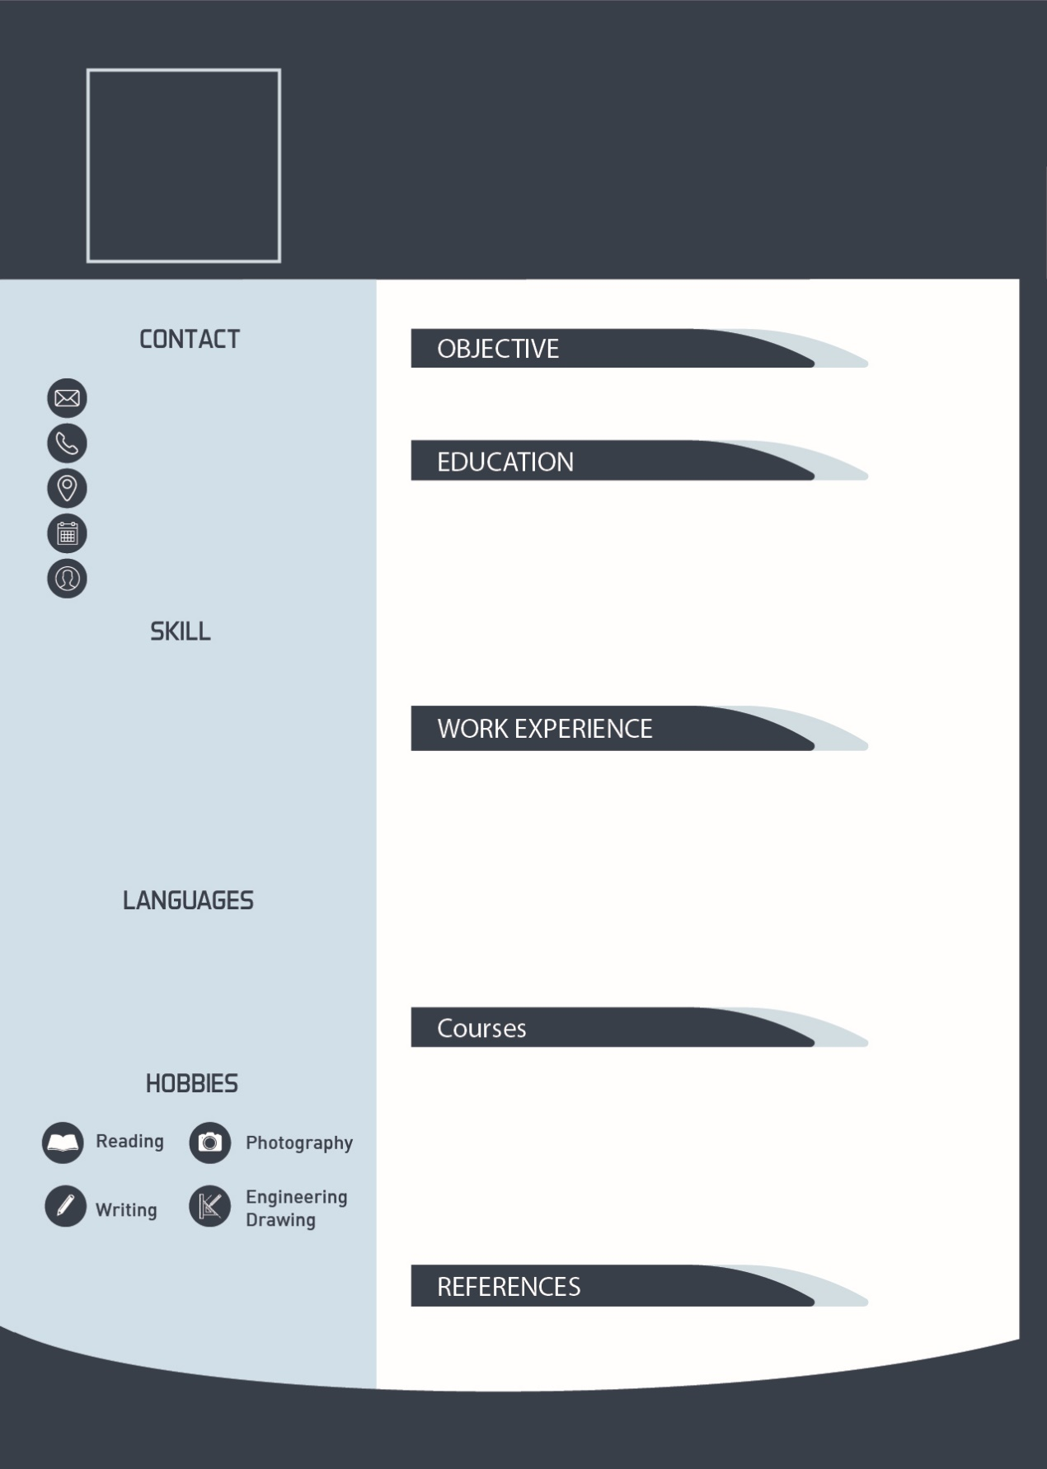 Yaser Mohammed’s CV

GRAPHIC DESIGNER

My Objective is to find a suitable job that help me to improve and success in my career …..etc

yas@gmail.com

0097123456789

Dubai, UAE

Date of Birth

Single

* Diploma in G. Design – 3.5/4 – ABC University
* Bachelor in G. Design – 3.7/4 – ABC University
* Master in G. Design – 3.9/4 – XYZ University
* Computer Skills
* Soft Skills
* Office skills
* Adobe Creative
* Etc….

* Training – ABC University – 6 Months
* My first job – ABC Company – 2017 to 2018
* My Second Job– XYZ Company – 2018 to current

[GetFreeCV.com](https://www.getfreecv.com)

* Ahmed Ali, DXV Designers - 050123456789
* Arabic (Fluent)
* English (Very Good)
* 2017: Time Management Course – ABC Institute
* 2017: Team work Course – ABC Institute
* 2018: G. Design labs course – AKO Institute